Bill Y. Tomiyasu Elementary School
Parent and Family Engagement Plan
2016-2017

Mission Statement: The mission of Bill Y. Tomiyasu Elementary School is established with the belief that all children can learn. This is accomplished through a partnership with school, parents, and community.

- This policy has been jointly developed and agreed upon by the staff of Tomiyasu Elementary School and parents of our students.
- Tomiyasu ES will convene an annual meeting, at a convenient time for parents, to evaluate this policy. This meeting will be held following a PTA meeting on Tuesday, September 13, 2016 at 4:30 pm in the Tomiyasu library. The School’s Parent and Family Engagement Plan, developed by staff and parents, will be distributed in an understandable and uniform format and to the extent practicable, in a language parents can understand. The parent and family engagement policy will also be made available to the community.
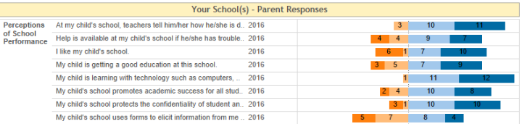
- The results of the annual District Wide Parent Survey revealed approximately 24 parents, 245 students, and 73 staff members gave feedback on the 2016 survey. Results of the parent survey are shown below. The results of parent, student, and staff responses will be shared with families at the meeting on September 13. These results will be used to guide the discussion of changes that need to be made to the Parent and Family Engagement Plan for Tomiyasu ES.

- Tomiyasu ES will involve parents in an organized, ongoing, and timely way in our planning, review, and improvement of Title 1 programs, school improvement plan, and parent involvement policy. Information about dates and times for parent planning meetings for the PFEP, School Performance Plan, and Title I budget will be sent home via the school newsletter and Parentlink messages. Administration will also verbally remind parent representatives of meetings when they are seen on campus.

- The Educational Involvement Accords are integrated into the registration process through Infinite Campus. Parents must review Accords prior to completing their child’s registration. Administrators and teachers will have access to the Accords whenever needed for parent/student conferences or other occasions.

- Tomiyasu ES builds parents’ and family members’ capacity or involvement in order to improve student academic achievement by doing the following.
- Assistance is provided through parent-teacher conferences, school newsletters, and FACES classes to parents and family members in understanding:
- the Nevada Academic Content Standards (NVACS)
- the CCSD Curriculum Guide that contains the Nevada Academic Content Standards
- our state tests, school district assessments, and school assessments
- proficiency level targets for students on the assessments used
- current data that shows their child’s academic progress toward Nevada’s standards
- the curriculum used at Tomiyasu ES including our reading and math programs and strategies
- how to monitor their child’s progress on Infinite Campus
- how to work with school staff to improve the achievement of students
- Teachers provide parents with paper materials and websites with login information to help parents & families work with students to improve their academic achievement and to foster parent and family engagement. Teachers explain how to use the materials to the parents and families so they can be successful at home.
- Teachers and staff are trained in how to reach out to, communicate with, and work with parents and family members as equal partners through the Site Based Collaboration Time on Wednesday afternoons. To build the ties between parents and family members with the school we provided classes taught by the Family and Community Engagement Services department (FACES) and family nights three times per year focusing on literacy and math activities and instructional strategies.
- Tomiyasu ES ensures that information related to the school and parent programs, meetings, and other activities is sent to parents and family members through monthly newsletters, flyers, and Parentlink messages. District provided materials and FACES materials that have been translated into Spanish are used. Parentlink messages are provided in both English and Spanish.
- Tomiyasu ES coordinates and integrates parent involvement programs and activities with Watch D.O.G.S. (Dads of Great Students), PTA (Parent Teacher Association), and FACES (Family and Community Engagement Services). Families are encouraged to participate in these programs as a way to become more involved in their child’s education.
- Tomiyasu ES provides reasonable support for parent involvement activities as parents may request. We use surveys completed at parent conferences, and information from the district-wide parent surveys to collect information. Child care will be provided during FACES classes when needed.

