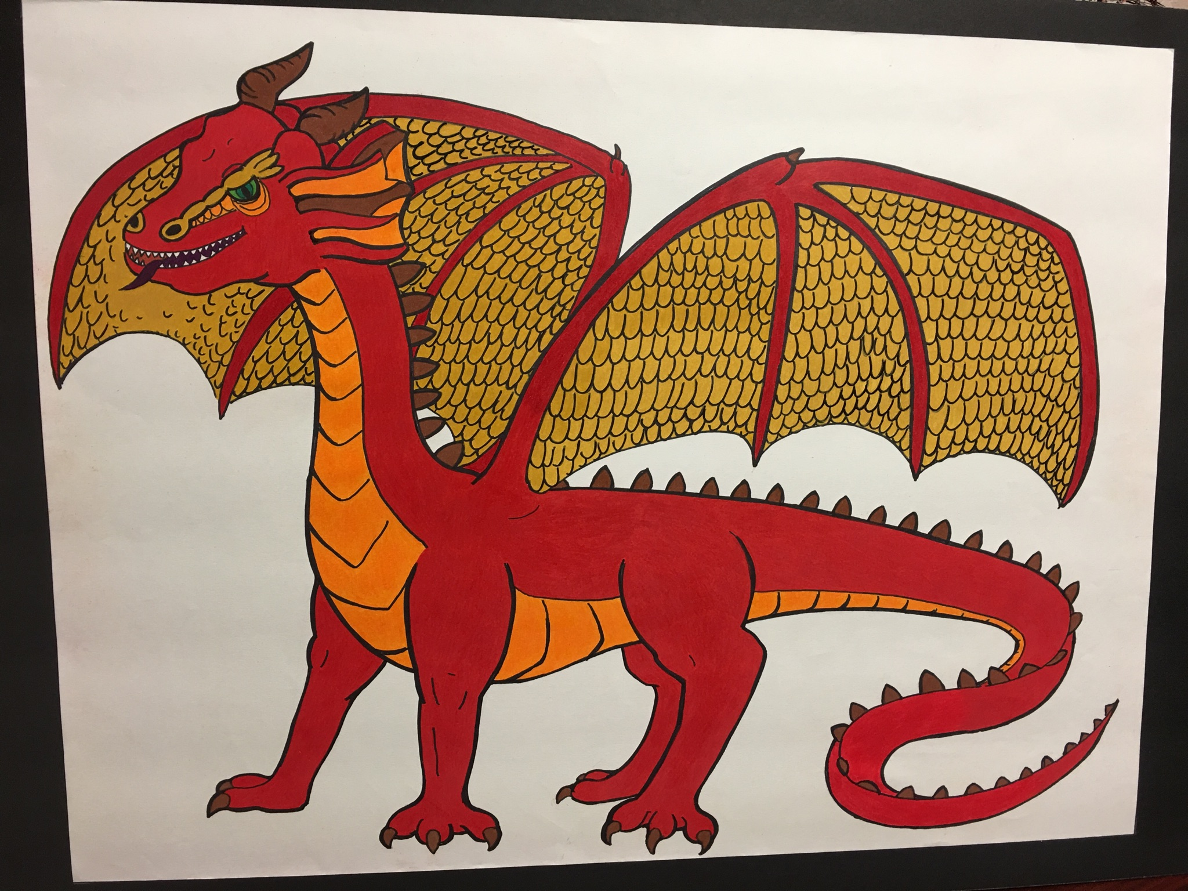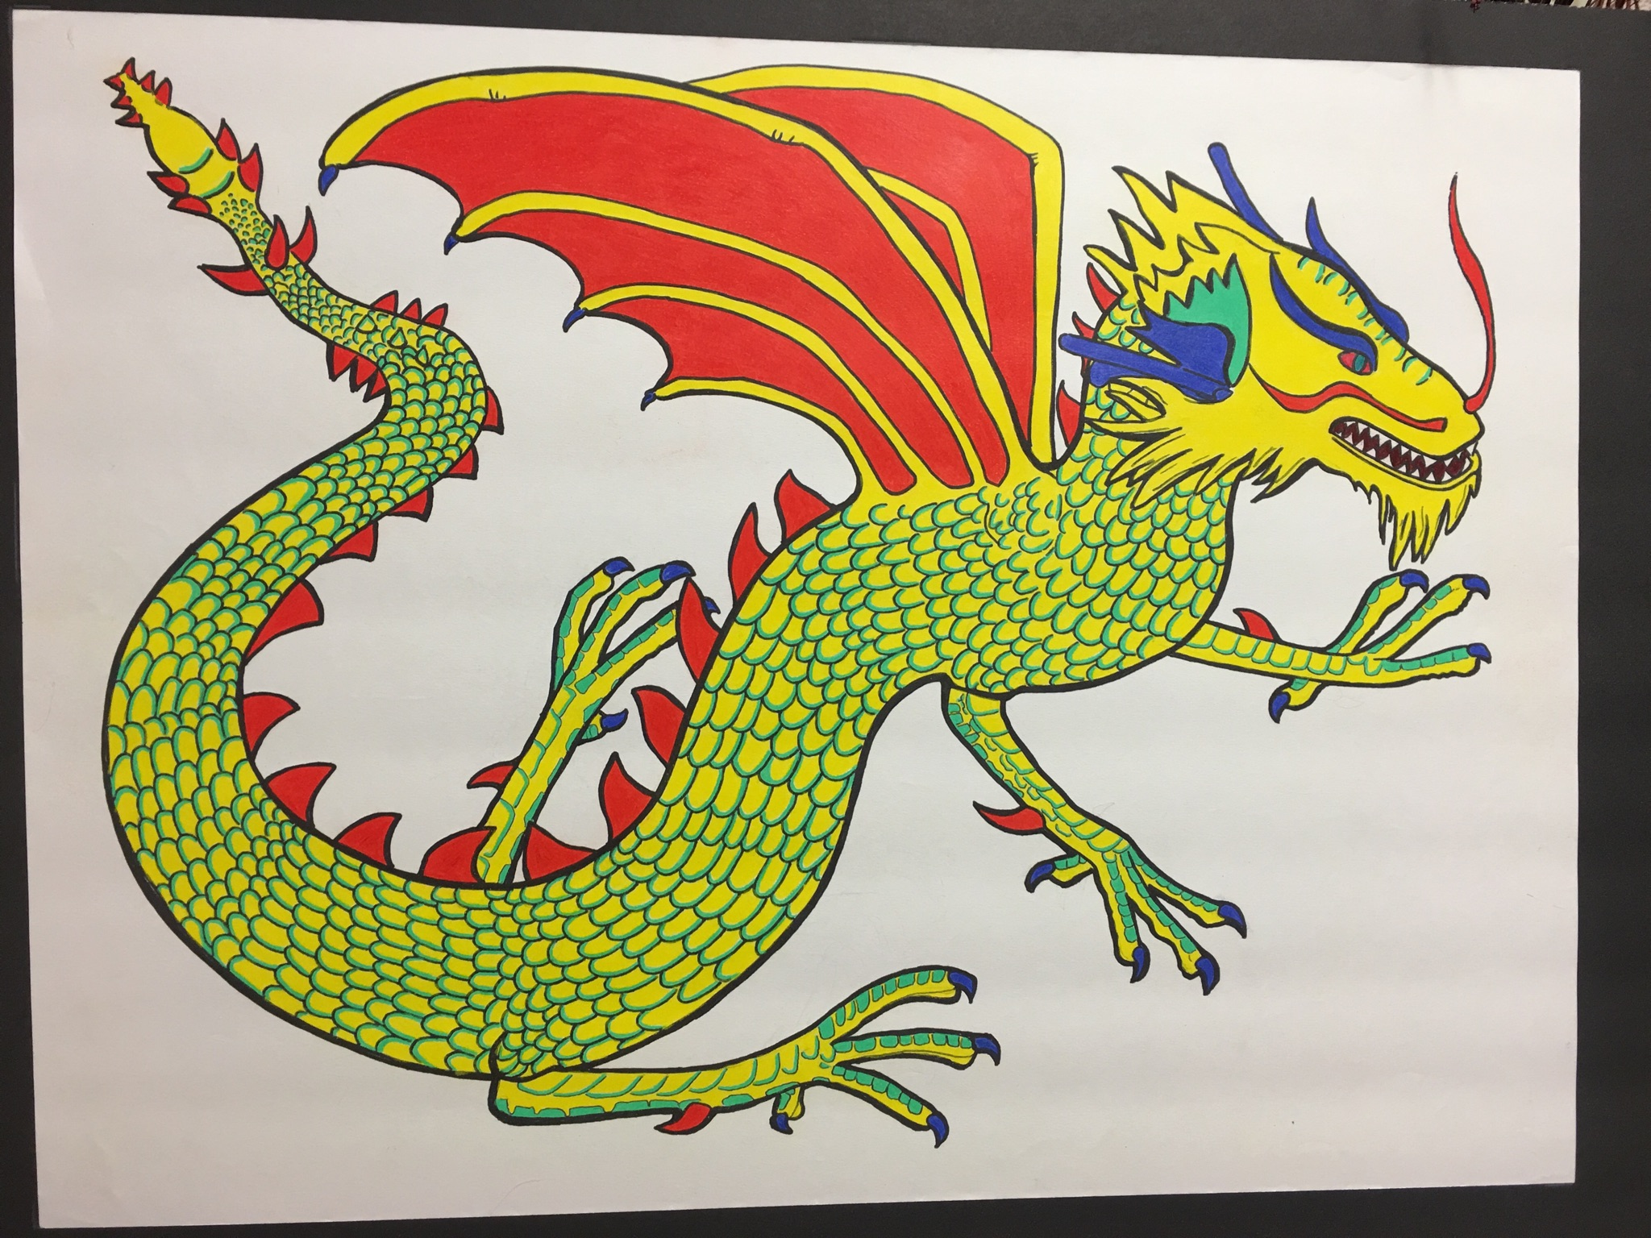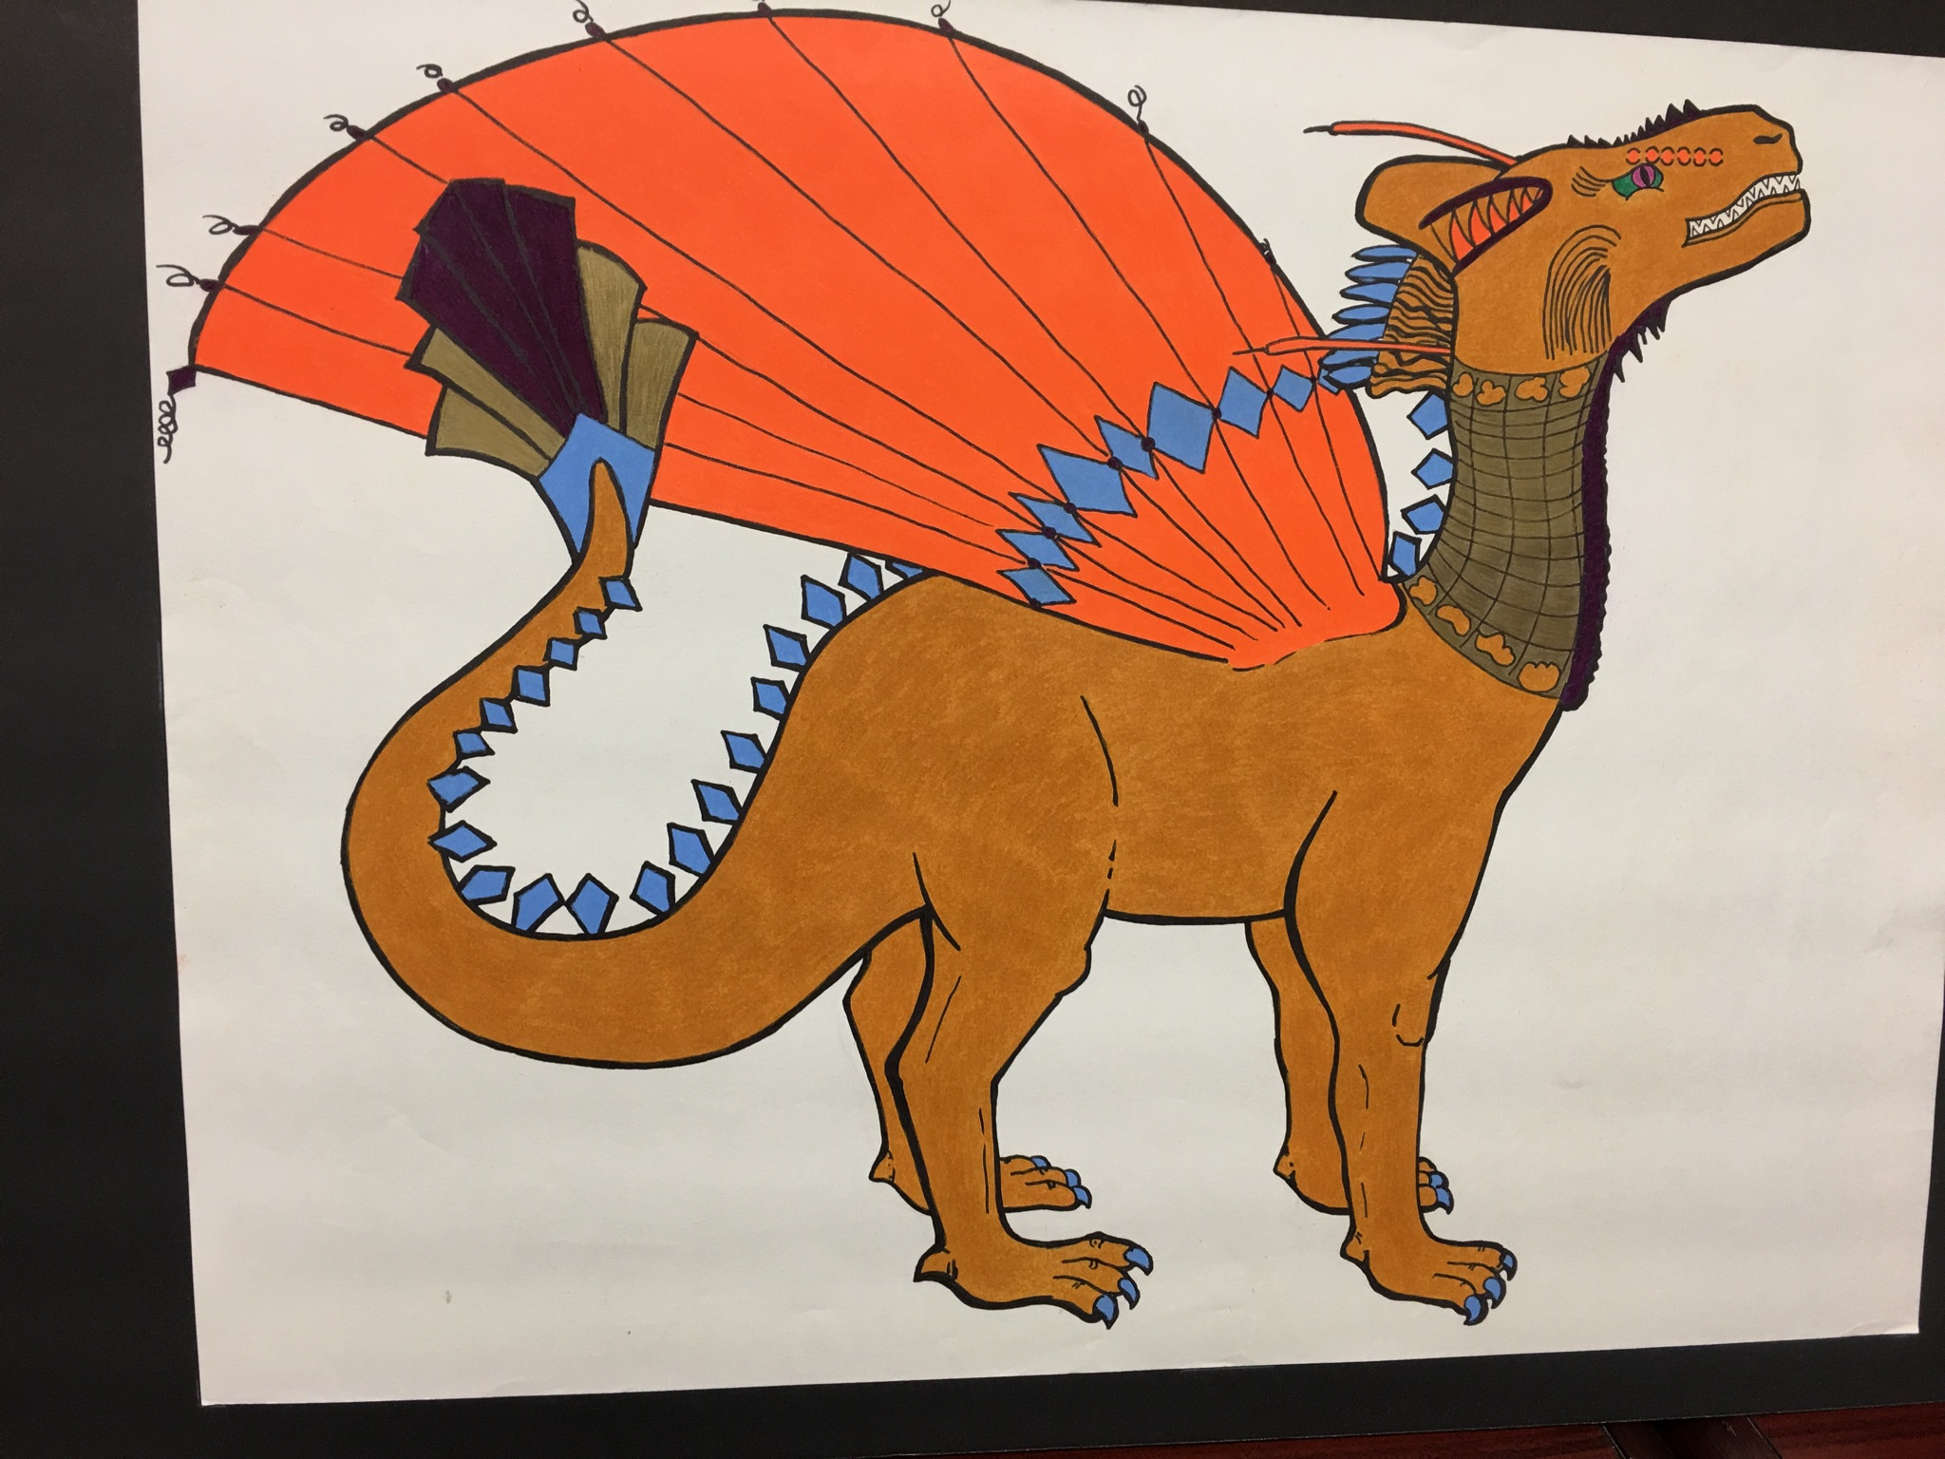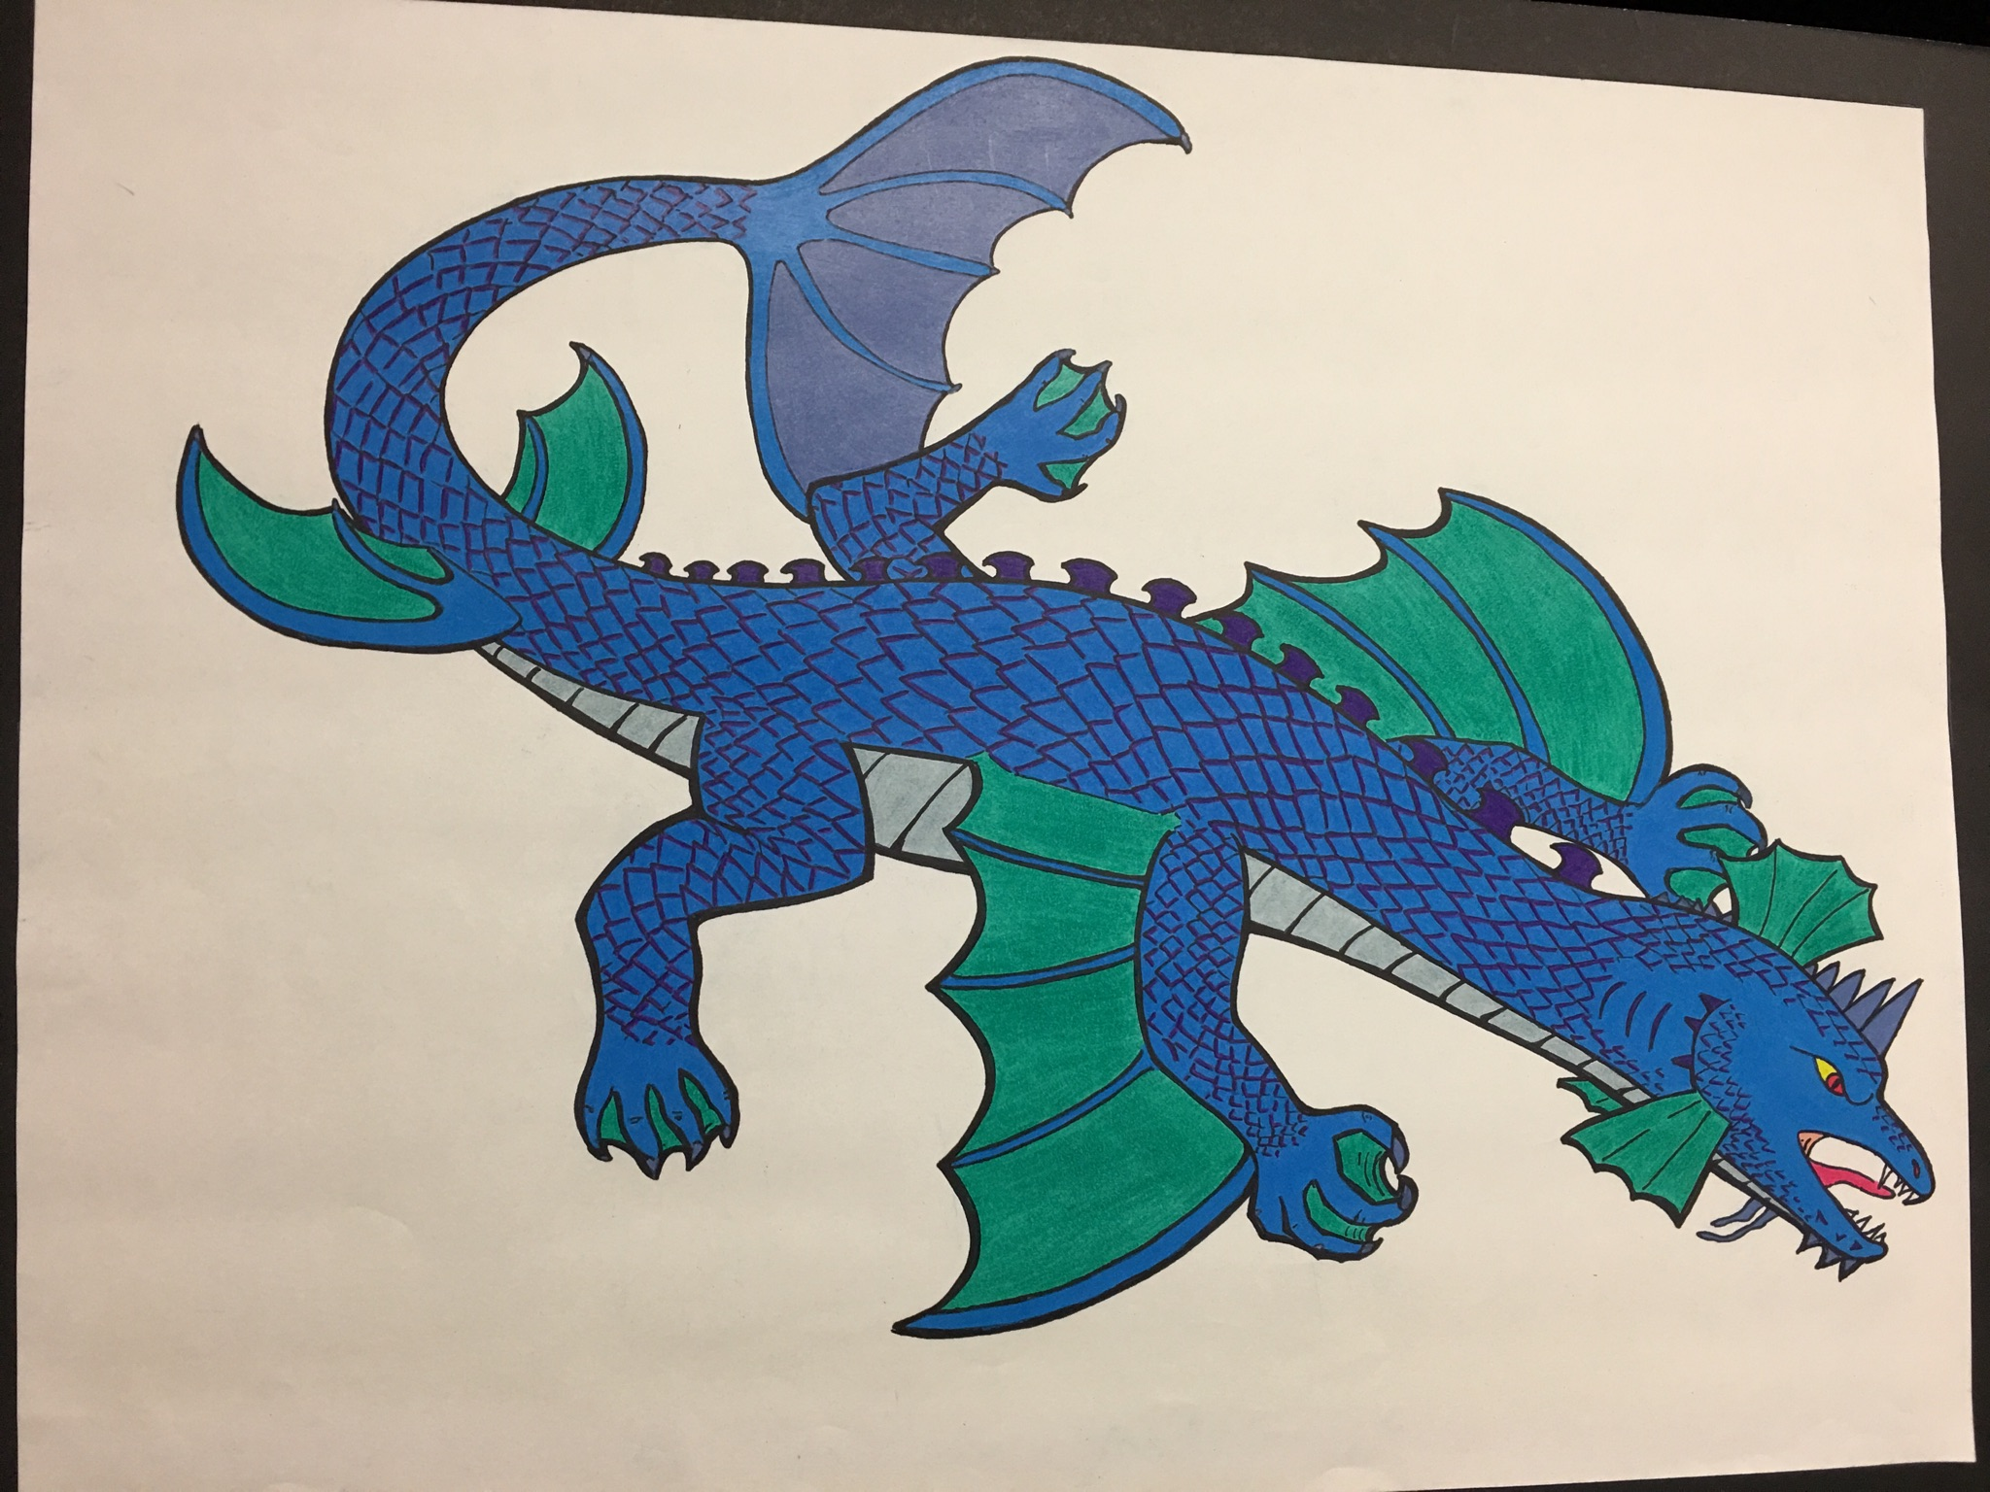

September has already been a busy month for the Tomiyasu community. Open House was September 7th and was a great success. It was nice to see so many families walking the Tomiyasu hallways.

September 8th was the official count day of student enrollment to determine staff allocations. Unfortunately, our student enrollment has decreased by about 100 students; and therefore, we will be losing two teachers. We are very sad to be losing Mrs. Rodriguez and Mrs. LaPlant, but we wish them well as they move to new schools. Starting October 13th, Mrs. Palmer’s kindergarten class will be divided among the other kindergarten classrooms. Mrs. Palmer will take over Mrs. Rios’ first grade class. Mrs. Rios will be teaching 4th grade. We will also create a combination classroom consisting of 4th & 5th grade students. These students will be taught by the 5th grade teachers. Letters about specific class changes will be sent home this week. On September 26th, the SOT met to discuss these items, and voted to approve this plan.

This year, we are working hard to build a stronger school community. Each classroom is part of a dragon team. We have the Rockin’ Rockstars, team Fuego, team Valiente, and team Thunder. All students participated in drawing different body parts of the dragon during Art class, and Mr. Allison then joined the body parts together. Teams then voted on a dragon name. Workboards showing student drawings and the final drawings are posted in the

multi-purpose room for everyone to see.

Thank you, Mr. Allison, for overseeing the

drawings! Ask your student which

dragon is his/her team mascot.

#### **September**

#### 29 Dragon of Month lunch

#### **October**

#### 2-6 Respect Week

#### 4-5 Gotcha Store open at lunch

#### 6 Wear Blue Day

#### Intervention Plans home

#### 13 Progress reports & UNSATS

#### Home

#### 16-20 College Awareness Week

#### 20 KIDS Day

#### Stuco applications due

#### 6:00 pm Trunk or Treat

#### 24 Make up picture day

#### 26 9 am Patriotic Assembly – 4th

#### Dragon of Month lunch

#### 27 No school – Nevada Day

#### 30 Stuco speeches & posters due

#### **November**

#### 6-9 Parent Conferences

#### 10 No School – Veterans Day

#### 17 KIDS Day

#### 20-24 No School – Thanksgiving

#### 28 & 29 5th grade field trip to

#### Regional Justice Center

#### For complete calendar information visit our Google calendar on the website at

#### **schools.ccsd.net/Tomiyasu**

#### 

### Calendar

# Principal’s Corner

##### Renee Muraco, Principal

##### Jo Imlay, Assistant Principal

Bill Y. Tomiyasu ES 5445 Annie Oakley Drive, Las Vegas Nevada 89120 702-799-7770

Tomiyasu Times

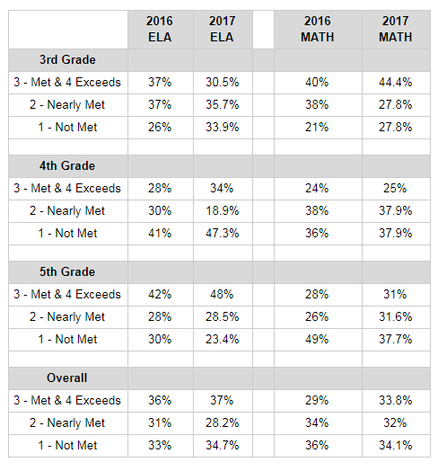

Each year the school must write a School Performance Plan that identifies goals, measureable objectives, and action steps designed to increase the academic achievement of all students. A committee of staff members as well as the School Organizational Team (SOT) come together to analyze data, set objectives, and devise action steps to help our students achieve a higher level of success. The district gave all schools the following goals:

* Increase grade 3 proficiency in reading
* Reduce the overall achievement gap percentage between highest performing ethnic/racial subgroups in both reading and math

Tomiyasu staff and SOT set the following action steps to achieve the goals:

* Professional development on Tier 1 small group differentiated instructional strategies using more technology
* Increase the amount of authentic learning through problem based learning strategies
* Provide Tier II & Tier III interventions in reading and math to help struggling students
* Provide parent trainings and curriculum nights to assist parents with intervention strategies

**2016 and 2017 SBAC Data for Tomiyasu**



### Tools for Life

Each week at Tomiyasu we focus on a characteristic that promotes a positive life. We bring these characteristics into the classroom community.

9/25 Patience

10/2 Respect

10/9 Curiosity

10/16 Effort

10/23 Perseverance

10/30 Courage

11/6 Organization

11/13 Flexibility

11/27 Common Sense

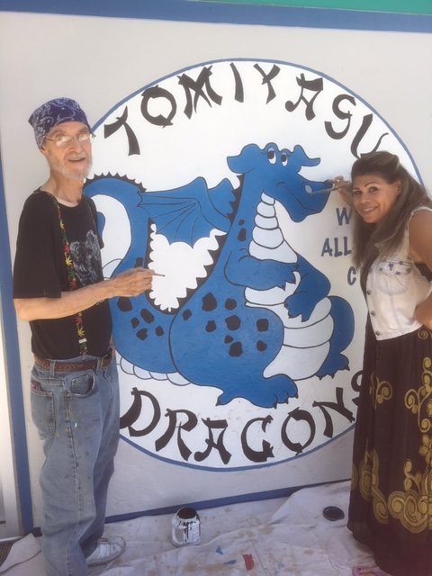

We want to give a special thank you to Michelle Artman and Thomas Bisesti for repairing and repainting the mural of our Tomiyasu Dragon, Ryuu. These two artists donated their talents, time, and supplies to brighten up Ryuu on the front of the building.   
  
**Ryuu looks amazing!**



**Friday, October 20th**

**6:00 pm**

PTA will be sending information home soon!

**Tomiyasu Website**

**Schools.ccsd.net/Tomiyasu**

If you want to stay current on everything Tomiyasu, then check out our new and improved website! The website offers information about the school, staff, curriculum, events, calendar information and CCSD links.

**School Organizational Team**

**(SOT) ELECTIONS**

We only had 1 parent submit a nomination form and be elected onto the SOT. We then had 1 parent volunteer to join the team. We are still short 1 parent. If you are willing to sit on this important committee that helps make decisions about Tomiyasu please see a member of the office.

**Our next meeting will be in mid-October. The exact date and agenda will be posted on the Tomiyasu website.**

**FREE Breakfast Program**

**Tomiyasu continues to offer FREE breakfast to all students for the 2017-2018 school year.**

This is a good time for students to fuel their bodies so their brains can focus on learning instead of on a grumbly tummy. Students may enter campus at 8:30 am through the gate on the Mesa Verde side of the school. Last year approximately 24% of our students took advantage of the free breakfast. This year we are required to have 60% of our students eat breakfast at school. In an effort to reach this goal all students will enter campus through the gates on Mesa Verde, walk through the cafeteria where they will be asked if they want breakfast and receive a hand stamp. If students want breakfast they collect their food items, and eat at that time; if students do not want breakfast they will walk through the cafeteria to the exit door, and may proceed to the playground. Teachers check hand stamps each morning to ensure that every student was given the opportunity to eat breakfast. Students who are late are asked if they want to eat prior to going to class. Breakfast is served until 10 am each day.

**Title I**

**Parents’ Right-to-Know**

The *Every Student Succeeds Act (ESSA)* was passed by the U.S. Congress and signed into law on December 10, 2015. The *ESSA* replaces the *No Child Left Behind Act (NCLB)* and is the latest reauthorization of the *Elementary and Secondary Education Act (ESEA).*

Although *NCLB* was designed to make changes in teaching and learning in order to increase students’ academic achievement, the Highly Qualified Teacher (HQT) provision under *NCLB* was eliminated from the *ESSA*. Despite this fact, all educators in Nevada still are required to hold the appropriate state certificate/license for their given position.

Under *ESSA*, all schools receiving Title I funds must inform parents of their right to ask schools about the professional qualifications of their child’s teachers. If you would like to view a teacher’s license, please access this link: <http://nvteachersearch.doe.nv.gov/>.

Parents are encouraged to support their child’s education and communicate with their child’s teacher(s) on a regular basis. For more information on *ESSA* and the role of parents, please visit the United States Department of Education’s website at <https://www2.ed.gov/policy/elsec/leg/essa/index.html>.